**JUnit Testing Exercises**

**Exercise 1: Setting Up Junit &**

**Exercise 2: Writing Basic JUnit Tests**

**Calculator.java:**

public class Calculator {

public int add(int a, int b) {

return a+b;

}

}

**CalculatorTest.java:**

import static org.junit.Assert.*assertEquals*;

import org.junit.Test;

public class CalculatorTest {

*@Test*

public void testAdd() {

Calculator calc = new Calculator();

int result = calc.add(2, 3);

*assertEquals*(5, result);

}

}

**OUTPUT:**

**Test Passed:**

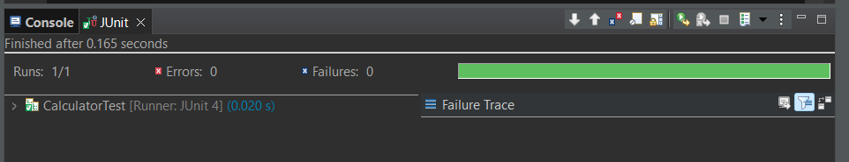

**Test Failed:**

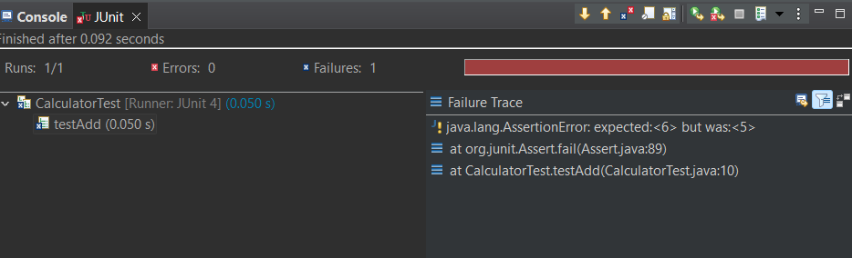

**Exercise 3: Assertions in Junit**

**AssertionTest.java**

import static org.junit.Assert.*;

import org.junit.Test;

public class AssertionsTest {

*@Test*

public void testAssertions() {

// Assert equals

*assertEquals*(5, 2 + 3);

// Assert true

*assertTrue*(5 > 3);

// Assert false

*assertFalse*(5 < 3);

// Assert null

*assertNull*(null);

// Assert not null

*assertNotNull*(new Object());

}

}

**OUTPUT:**

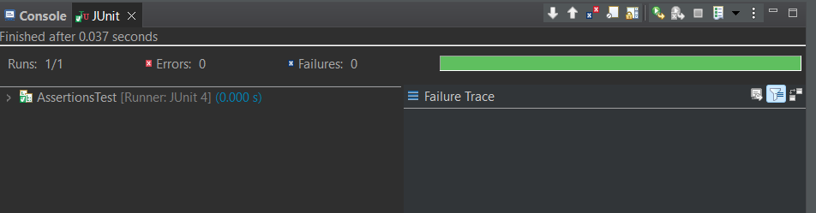

**Exercise 4: Arrange-Act-Assert (AAA) Pattern, Test Fixtures, Setup and**

**Teardown Methods in Junit**

**CODE:**

**CalculatorAAATest.java**

import static org.junit.Assert.*;

import org.junit.Before;

import org.junit.After;

import org.junit.Test;

public class CalculatorAAATest {

private Calculator calculator;

*@Before*

public void setUp() {

calculator = new Calculator();

System.***out***.println("Before Testing");

}

*@After*

public void tearDown() {

calculator = null;

System.***out***.println("After Testing ");

}

*@Test*

public void testAdd() {

int a = 10;

int b = 5;

int result = calculator.add(a, b);

*assertEquals*(15, result);

}

}

**OUTPUT:**

